The Centre of Hope’s SUBZERO CHALLENGE includes the Annual Fire on Ice. Fire on Ice is to raise awareness for the thirty plus individuals experiencing homelessness in our region at any giving time. Individuals living rough are very resourceful with building their shelters to staying safe in our extreme winter climate and let’s see how we do!
Fire on Ice participants will learn essential survival skill, how to build a quinzee/shelter and weather the winter/spring elements for 24 hours in a camping like scenario. If you’re adventures, love the outdoors, and would like to experience this one-of-a-kind experience then this event is for you. Wait…you will be with experienced outdoor survivalist, James Marten from Search and Rescue and friends with Rosie Keating from Centre of Hope, as she has been a part of this event for many years.
Centre of Hope is Fort McMurray’s only daytime drop in facility serving individuals experiencing homelessness or near homelessness in our region. Currently the Centre sees over fifty visitors a day. Our programs provide individuals with further assistance to services such as, booking and accompanying them on appointments, assisting with phone calls, rides, bus tickets, treatment papers, advocating for them as well as a listening ear.
Participants will raise funds in the form of pledges and all funds raised from this event will go directly to the 2022-2023 Sub Zero Challenge for the drop-in, intake and outreach programs at the Centre. Wish is for each participant to raise a $1,000 or more for building a shelter and spending the night for the Subzero Challenge.
Date: February 25, 20223
Location: Aostra Road, 25kms north of Fort McMurray
Time: 8:00am – 8:00am
Breakfast: TBA (will arrange breakfast at a local restaurant in Fort McMurray)

The below list will prepare you for fire on ice and how to cope with dealing with the elements for 24hours.
Survival Supplies:
- Shovel and Knife (knife for twigs)
- Clothing
  - Change of clothes is recommended (after you build your quinzee, recommendation is change out of these wet clothes into dry ones to prevent a chill) and before you go to bed remove any damp clothing for dry.
  - Layering is recommended for wind, rain, snow for all the weather elements
  - Socks, gloves, neck warmer, toque, pants, and jacket – extra of each
- Food
  - Energy bars, canned, dried, food so items don’t freeze (hotdogs, buns, beans, & chips)
  - Water in an insulated bottle so it does not freeze
- Pots, can opener, silverware, plates, and garbage bags
- Flashlight, Kleenex, Paper towels, toilet paper, candles, sanitizer
- Emergency Candles & lighter or matches
- Sleeping
  - Tarp, wool blanket, sleeping bag. The more layers underneath is better
  - Emergency shelter & Emergency blankets

Items provided: Firewood and side by sides and/or snowmobiles
Participants will arrive at Aostra road meeting point and are able to walk to the campsite or utilize the side by sides and snowmobiles. Your safety is very important!
Guides will provide support throughout the day and evening.

Information session will be provided prior to the date.

Build a Quinzee ~ view YouTube view outsidefun1
- Pile snow in one area
- Snow pile sits for 1 hour up to four hours to harden
- Collect 24 twigs about 12-18 inches in length for wall thickness markers
- Walls to be one foot thick
- Floor 6 inches higher than entrance
- Vent in ceiling
- Now it’s time to glaze the interior as well as add warmth and ambiance with a tapered candle
- Sleeping gear – tarped, thermal/wool blanket, and a sleeping bag
- Change of clothes – while building the quinze you’ll work up a sweat. Once complete, it’s important to change out of any damp clothes and into warmer gear
- Entrance practically closed at night to keep the heat in. Place backpack in entrance to block the wind

How to build a snow shelter ~ quinzee shelter
Quinzee is basically a large pile of snow, a mound/dome shape, that has been hollowed out, thus making for a cave-like place to rest, sleep, keep yourself alive and so forth.
- Pile snow in a mound/dome shape. Make the pile about as high as a tall person. The total length at the base of the pile should be about four feet longer than the tallest person the shelter will house.
Let the snow settle for at least an hour to four hours. This step is crucial because it gives the quinzee structural integrity
- Pierce sticks in through the roof and walls of the shelter every couple feet. Sticks play a crucial role in helping mark the wall and roof thickness when you dig the center.
Length of every stick should be about 12-18 inches long, which relates to a 12–18-inch walls and ceiling.
Now excavate! Begin by creating a small door the width of the resident to squeeze through and located on the lowest side. Allows for minimum heat loss. Eventually you will have to lay down on the snow in order to continue digging out the cave. When you find yourself in this position, congratulate yourself. The door is complete. Excavate upward as well as inward.
- Do not dig beyond the ends of the sticks
- Ensure the lowest spot is inside the shelter near the door.
- Level and elevate a sleeping platform, as heat 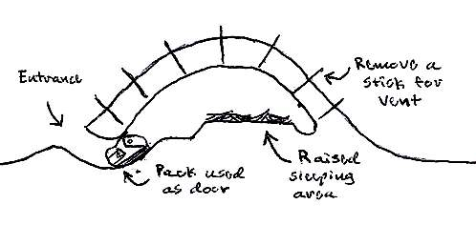
Smooth out the interior of the dome and create a small trench all around your sleeping platform, this will keep melting snow water from getting you and your gear wet.

Remove a couple of sticks for ventilation holes. All snow shelters must have ventilation to allow oxygen to get in and to vent out carbon dioxide.

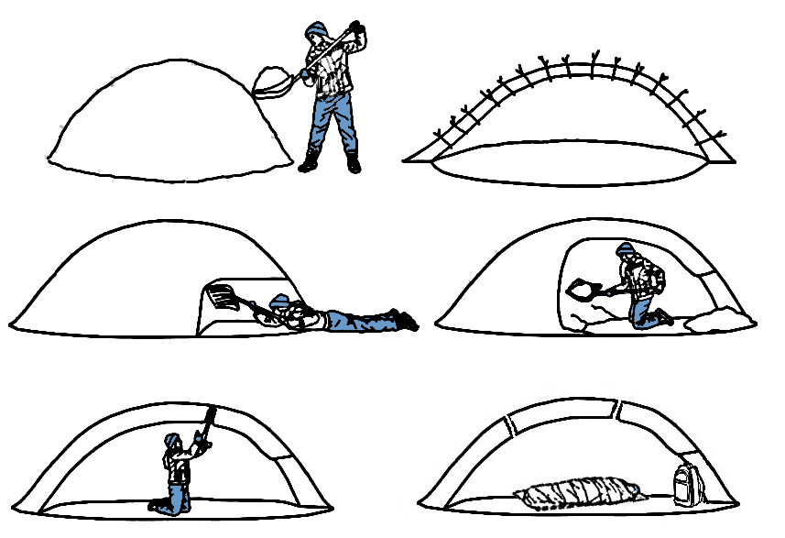
Stay hydrated and change your clothes for warmth!
Now it’s time to gather firewood and have more fun and learn some more survival skills!

